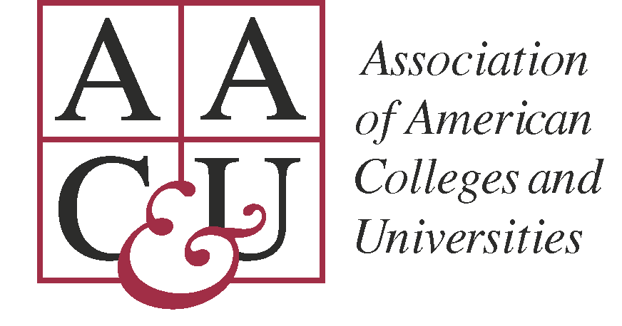
For Immediate Release

Contact:
Debra Humphreys, Vice President for Communications and Public Affairs
Humphreys@aacu.org
202.884.7422

Ten Institutions Chosen to Form Community College Network Focused on Civic Learning through the Humanities

Supported by NEH and co-sponsored by AAC&U and The Democracy Commitment, Bridging Cultures to Form a Nation: Difference, Community, and Democratic Thinking, Will Build Campus Capacity for More Effective Forms of Civic Learning through the Humanities
Washington, DC—April [x], 2012—The Association of American Colleges and Universities (AAC&U) and The Democracy Commitment: An American Community College Initiative (TDC) announced today the names of ten community colleges competitively chosen to take the lead in a new initiative funded by the National Endowment for the Humanities.

Selected institutions include:

Chandler-Gilbert Community College
City University of New York, Kingsborough Community College
County College of Morris
Georgia Perimeter College
Kapi‘olani Community College
Miami Dade College
Middlesex Community College
Mount Wachusett Community College
Lone Star College-Kingwood
Santa Fe College

Teams from each of these schools will participate in Bridging Cultures, a three-year curriculum and faculty development project designed to:

- infuse questions about difference, engaged community, and democratic thinking into transfer courses in the humanities;
- promote greater adoption of proven high-impact practices that advance important civic learning outcomes;
- create a series of humanities-enriched professional development opportunities for community college faculty, especially adjunct faculty; and
- expand the project’s impact through collaboration with additional community colleges and partnerships with state humanities councils.

“The community colleges chosen for this project are poised to lead the way in developing curricular and co-curricular practices steeped in the humanities and designed to prepare students to be active and engaged participants in the democratic process,” said Brian Murphy, president of De Anza College, one of the founders of The Democracy Commitment, and a co-director of the Bridging Cultures project. “The entire Democracy Commitment network will benefit greatly from the work these schools will do together over the course of this project.”

“The community colleges in this NEH Bridging Cultures project are answering the national call to action embedded in the recently released national report, A Crucible Moment: College Learning and Democracy’s Future,” said AAC&U Senior Vice President and NEH project co-director Caryn McTighe Musil. “They are targeting high-enrollment humanities courses and adopting proven civic pedagogies that together will offer more students opportunities to increase their knowledge, skills, and commitments to making our multicultural democracy in the United States stronger and more effective.”

Bridging Cultures was developed as part of AAC&U’s ongoing initiative on Civic Learning and Democratic Engagement and builds on the recommendations issued in the report, A Crucible Moment: College Learning and Democracy’s Future, released in January 2012 at a White House convening. The key recommendation in A Crucible Moment is to make civic learning in college expected rather than optional for all students, including all those in career and technical programs. Building from this recommendation, Bridging Cultures to Form a Nation began in February 2012 with a call for proposals to community colleges across the country, leading to the selection of ten teams composed of humanities faculty and administrators. Team members will participate in an intensive summer faculty development institute in August 2012, as well as multiple other faculty development opportunities and partnerships with other community colleges. The project will culminate in a symposium planned for October 2014. Bridging Cultures’ impact will also be strengthened by a partnership with the New York Times Company education group, which is collaborating with TDC in their national initiative. Project participants will use the Epsilen online learning platform to develop forums and to share and co-create resources and course materials.

For additional information about the initiative, visit: http://www.aacu.org/bridgingcultures.

For a copy of the report, A Crucible Moment, see:
http://www.aacu.org/civic_learning/crucible/index.cfm

For information about AAC&U’s work in Civic Learning and Democratic Engagement, see http://www.aacu.org/civic_learning/index.cfm.

For more information about The Democracy Commitment’s mission, activities, and members, visit http://thedemocracycommitment.org.
About AAC&U
AAC&U is the leading national association concerned with the quality, vitality, and public standing of undergraduate liberal education. Its members are committed to extending the advantages of a liberal education to all students, regardless of academic specialization or intended career. Founded in 1915, AAC&U now comprises more than 1,250 member institutions—including accredited public and private colleges, community colleges, and universities of every type and size.
AAC&U functions as a catalyst and facilitator, forging links among presidents, administrators, and faculty members who are engaged in institutional and curricular planning. Its mission is to reinforce the collective commitment to liberal education at both the national and local levels and to help individual institutions keep the quality of student learning at the core of their work as they evolve to meet new economic and social challenges.
Information about AAC&U membership, programs, and publications can be found at www.aacu.org.
About The Democracy Commitment
The Democracy Commitment is a national initiative that provides a platform for the development and expansion of programs and projects aiming at engaging community college students in civic learning and democratic practice. The goal of the partnership is for every graduate of an American community college to have had an education in democracy, whether they aim to transfer to university, achieve an associate degree, or obtain a certificate.

For information and to become a member of The Democracy Commitment, visit: http://thedemocracycommitment.org.

